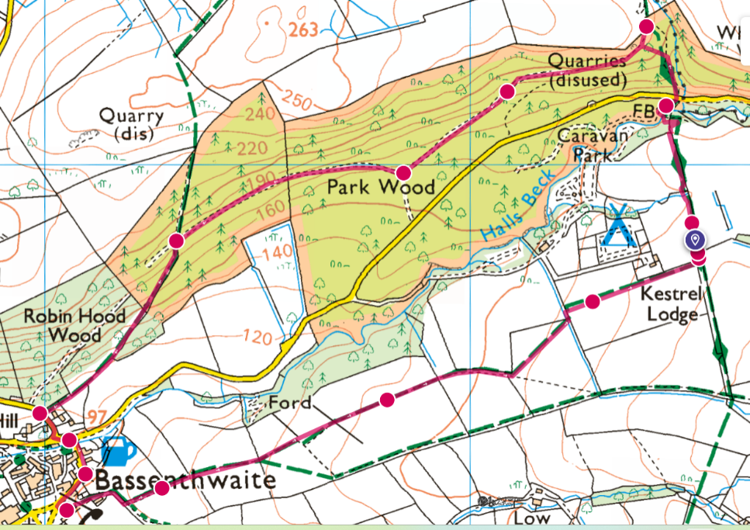
Short leg stretch to Bassenthwaite village and back
Distance = 4.5km or 2.8 miles
Average time = 1hour 30mins (not including a pub stop)

Start – Kestrel Lodge Campsite
- Head out onto the Cumbrian way. Ask at reception if you are unsure how to get onto the footpath from the site.
- Once you have met the Cumbrian way. Turn left and follow the edge of the field to a small stream.
- Cross the stream and go through the gate. Walk straight across the top of the field keeping the fence on your right.
- Once at the end of the field you will find a pedestrian gate. Go through this and walk diagonally below the old tree towards the next pedestrian gate.
- Go through this and left down to the stream. Have a paddle if you like and cross the bridge.
- Over the bridge turn right up to the minor road.
- Cross the road and go steeply up into the woods. All the way to the top. (it is a little scrambly) signed bridleway.
- At the top take a deep breath and follow the path left. Follow the path along the top of the woods (hopefully looking out at a fantastic view over Bassenthwaite village, lake and over at Skiddaw and the northern fells).
- A track will come in from your left, don’t take this unless you want to cut the walk short. Continue up the track until a gateway.
- The track will turn into a path, meander your way through the woods until you meet a junction. Take the path on the left down towards the fields. Follow the fence line to a road.
- Turn left at the road and into the village. Have a wander around there is a play area, pub and you may see the ducks on the stream. From here you can either walk up the road back to the site or go through the fields.
- Field route - With the pub (The Sun) on your right follow the road to the village green. Turn left at the bus stop / footpath sign up a dead-end road. You will go past a few houses and come to the end of the road and a gate.
- Go through this gate and follow the field up left keeping the fence on your left. Go through the gate at the top of the field.
- Walk up the middle of the next 2 fields. (the 2nd field is quite big) continue straight over the 3rd field heading to the top corner. (a fence will join you on your left.)
- In the 4th field go through the gate and walk diagonally left to the top left corner.
- Walk up the middle of the 5th field towards a hedge line. Continue and follow the hedge line and keep it on your left until you reach the top of the field.
- Turn left onto the Cumbrian way going through the pedestrian gate. Then access the Campsite where you started your walk.

